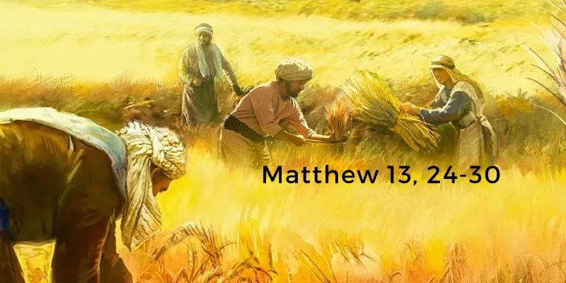
Next Sunday, 30 July, we will celebrate the baptism of George White, Theodore’s little brother, both of whom come to church each week with their parents.

After 24 years as Provost of the Cathedral, the Very Reverend Hunter Farquharson is retiring at the end of July. Hunter’s last service as provost will be Choral Evensong on Sunday 30th July at 3.00pm. The Vestry and Congregation extend a warm invitation to everyone in the Diocese and beyond to the Cathedral for this service. Bishop Ian will be in attendance and there will be refreshments after the service.
13 August is our Patronal Festival and we will be inviting St Margaret’s to join us. Revd Amos Chewachong will preach. Would a couple of people like to provide a loaf or buns for coffee time?

27 August Harvest Thanksgiving

Saturday 14 October at 2.30pm There will be an organ recital by Mark Spalding.

DIOCESAN PRAYER DIARY
Please pray for:
College of Bishops , Bishop Ian
Holy Trinity, Stirling
Christoph Wutscher, Deacon Rebekah Sims, Bishop John Crook, Val Nellist

Next Sunday 30 July. Pentecost 9
Organist ; David
Set up: Doreen
Reception Betty
Reader Janet
Intercessions Frank
Coffee Betty



St MARY’s
Scottish Episcopal Church
Charity no SC003380
www.stmaryschurchnewportontay.org

Revd. Kathy Barrable M Ed. M Th.
07552 503859
Grace and Peace be with you
23 July 2023 Pentecost 8

Welcome
Introit Hymn O for a closer walk with God 231
Collect for Purity
Confession
Absolution
Kyrie
Gloria
Collect of the Day
Readings Jane
Gradual Hymn Happy are they, they that love God 176
Gospel
Sermon
Creed
Intercessions Frank
Peace
Offertory hymn Holy Spirit, come confirm us 471
Eucharistic Prayer V p18
The Lord’s Prayer (sung) p20
Communion Song
Communion is now received
Post Communion Prayer
Blessing
Recessional hymn Thanks to God…… 423
Dismissal

WELCOME TO EACH VISITOR. We hope you enjoy God's message of faith, hope and love! We invite you to receive communion if you have been baptized.

Please be assured that the chalice is wiped with 99% food grade alcohol between each communicant. If you would rather receive the bread only, this is fine.

However, intinction (dipping the wafer into the wine) is NOT permitted.

