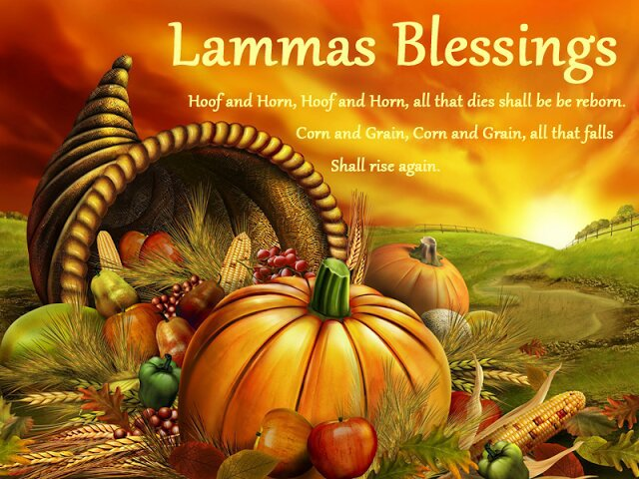
Lammastide - feast and thanksgiving aplenty!

Rootedness. You and I are deeply planted in tradition - family, culture, church and in the world. And so are the festivals which extend even way back into pagan times. Lammastide is one: August 1st is known as Lammas Day or as the Gaelic festival period of Lughnasadh. Lammas origins lie in the Christian liturgical calendar, its name deriving from the Anglo-Saxon hlaf-mas meaning loaf-mass. It marked a time when the agricultural year and the Christian calendar came together. From mediaeval times it marked the end of the hay harvest and the beginning of the grain. Our churches still dedicate a Sunday to thanksgiving for the harvest, which promises to be a bumper one this year, praise God!

All food donations today will be taken to the local foodbank.

SC003380

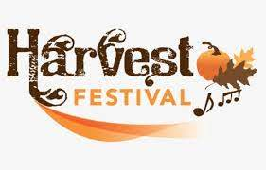

Welcome:
Grace and peace to you from God our Father and the Lord Jesus Christ

Introit Hymn

Call to worship
Priest: (from psalm 65: 1,9-10, 12-13)
Praise is due to you, O God, in Zion. You visit the earth and water it, you greatly enrich it; the river of God is full of water; you provide the people with grain, for so you have prepared it.

All: You water its furrows abundantly, settling its ridges, softening it with showers, and blessing its growth.

Priest: The pastures of the wilderness overflow, the hills gird themselves with joy

All: The meadows clothe themselves with flocks, the valleys deck themselves with grain, and they shout and sing together for joy Alleluia.

Confession
Jesus said “those who drink of the water that I will give them will never be thirsty” Jesus is the living water – so let us bring our secret sins to him and confess them in penitence and faith

Lord God, we stand on holy ground, because it is your created world – you offer us living water but we do so much that is wrong.
Lord, have mercy

We do not listen to you, we do not listen to those who cry from their hearts in sickness, pain, poverty and hunger.
Christ, have mercy

We speak before we hear and we think things we should not. Help us, good Lord, to be holy and to refresh others in the world with the living water of Christ.
Lord, have mercy
Forgive us good Lord, as we forgive others.

Priest: God, who is both power and love, forgive us and free us from our sins, heal and strengthen us by the Spirit, and raise us to new life in Christ our Lord.

The Gloria

Collect
Eternal God, you crown the year with your goodness and you give us the fruit of the earth in their season; grant that we may use them to your glory, for the relief of those in need and for our own wellbeing; through Jesus Christ our Lord, who is alive and reigns with you, in the unity of the Holy Spirit, one God, now and for ever. AMEN

LITURGY OF THE WORD


OT: Deuteronomy 8: 7-18
Psalm 65
NT: 2 Corinthians 9: 6-15

Gradual hymn:

Gospel: Luke 12: 16-30

Sermon

Baptismal Creed (said together)
I believe and trust in God the Father who made the world
I believe and trust in His Son Jesus Christ who redeemed all of humanity
I believe and trust in the Holy Spirit who gives life to the people of God
I believe and trust in one God, Father, Son, and Holy Spirit. Amen

Intercessions

The Peace
The altar is prepared during the offertory hymn

Offertory hymn

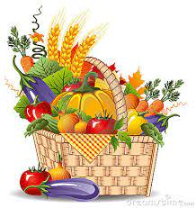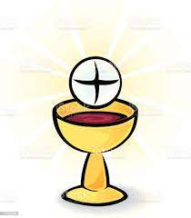

Offering
Priest: Let us present our offerings to the Lord

All: Yours, Lord, is the greatness, the power, the glory, the splendour, and the majesty: for everything in heaven and on earth is yours. All things come from you, and of your own we give you.

THE LITURGY OF THE SACRAMENT
(blue Liturgy booklet)

Eucharistic Prayer V p18
The Lord’s Prayer
Communion Song

COMMUNION IS NOW RECEIVED

Post communion prayer (said together)

Lord of the harvest, with joy we have offered thanksgiving for your love in creation and have shared in the bread and the wine of the kingdom; by your grace plant within us a reverence for all that you give us and make us generous and wise stewards of the good things we enjoy; through Jesus Christ our Lord. Amen.

BLESSING

Recessional hymn

Dismissal

