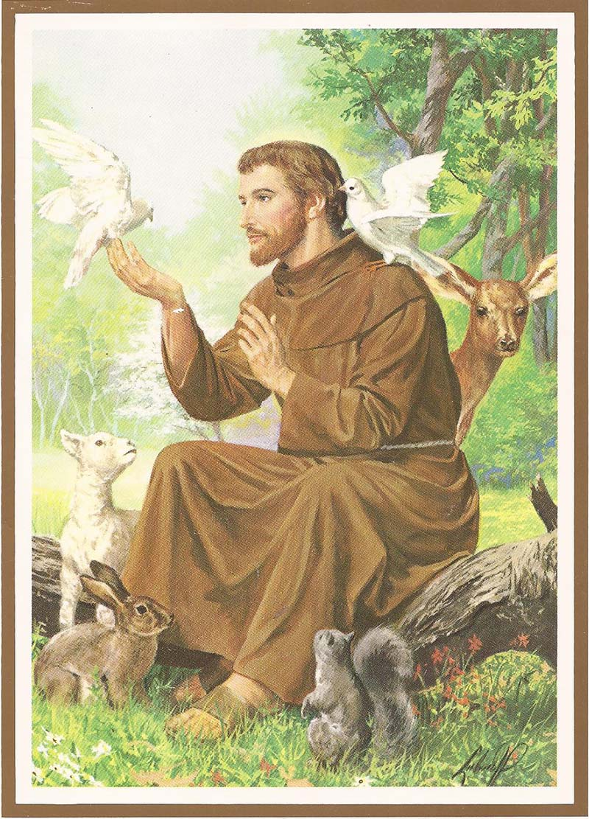

St Francis
There will be a pet blessing after the service and a retiring collection for the SSPCA

Next Saturday 14 October at 2.30pm.
Organ recital by Mark Spalding, followed by refreshments

Saturday 4th November at 11.30am
SECMA Service of Thanksgiving in St Mary’s Cathedral, Edinburgh.
See poster at the back of the church.

DIOCESAN PRAYER DIARY
Please pray for:
College of Bishops , Bishop Ian
St Mary, Aberfoyle with St Andrew, Callander
Jonathan Connell

Next Sunday 15 October 2023
Organist ; David
Set up: David
Reception Katherine
Reader Jane
Intercessions Callum
Coffee: Betty



St MARY’s
Scottish Episcopal Church
Charity no SC003380
www.stmaryschurchnewportontay.org

The Revd Kathy Barrable, MEd, MTh
07552 503859
Grace and Peace be with you

8 October 2023 St Francis

SEASON OF CREATION

Welcome
Introit Hymn Christ be our light Leaflet
Collect for Purity
Confession
Absolution
Kyrie (on laminated sheet)
Gloria (on laminated sheet)
Collect of the Day (back of leaflet)
Gradual Hymn O Lord, my God 198#
Gospel
Sermon
Nicene Creed
Intercessions Frank
Peace
Offertory hymn Make me a channel of your peace 173#
Eucharistic Prayer
The Lord’s Prayer (sung)
Communion Song (on laminated sheet)
Communion is now received
Post Communion Prayer (back of leaflet)
Blessing
Recessional hymn All creatures of our God and King 105
Dismissal

# New Hymns and Worship songs

WELCOME TO EACH VISITOR. We hope you enjoy God's message of faith, hope and love! We invite you to receive communion if you have been baptized.

Please be assured that the chalice is wiped with 99% food grade alcohol between each communicant. If you would rather receive the bread only, this is fine.

However, intinction (dipping the wafer into the wine) is NOT permitted.

