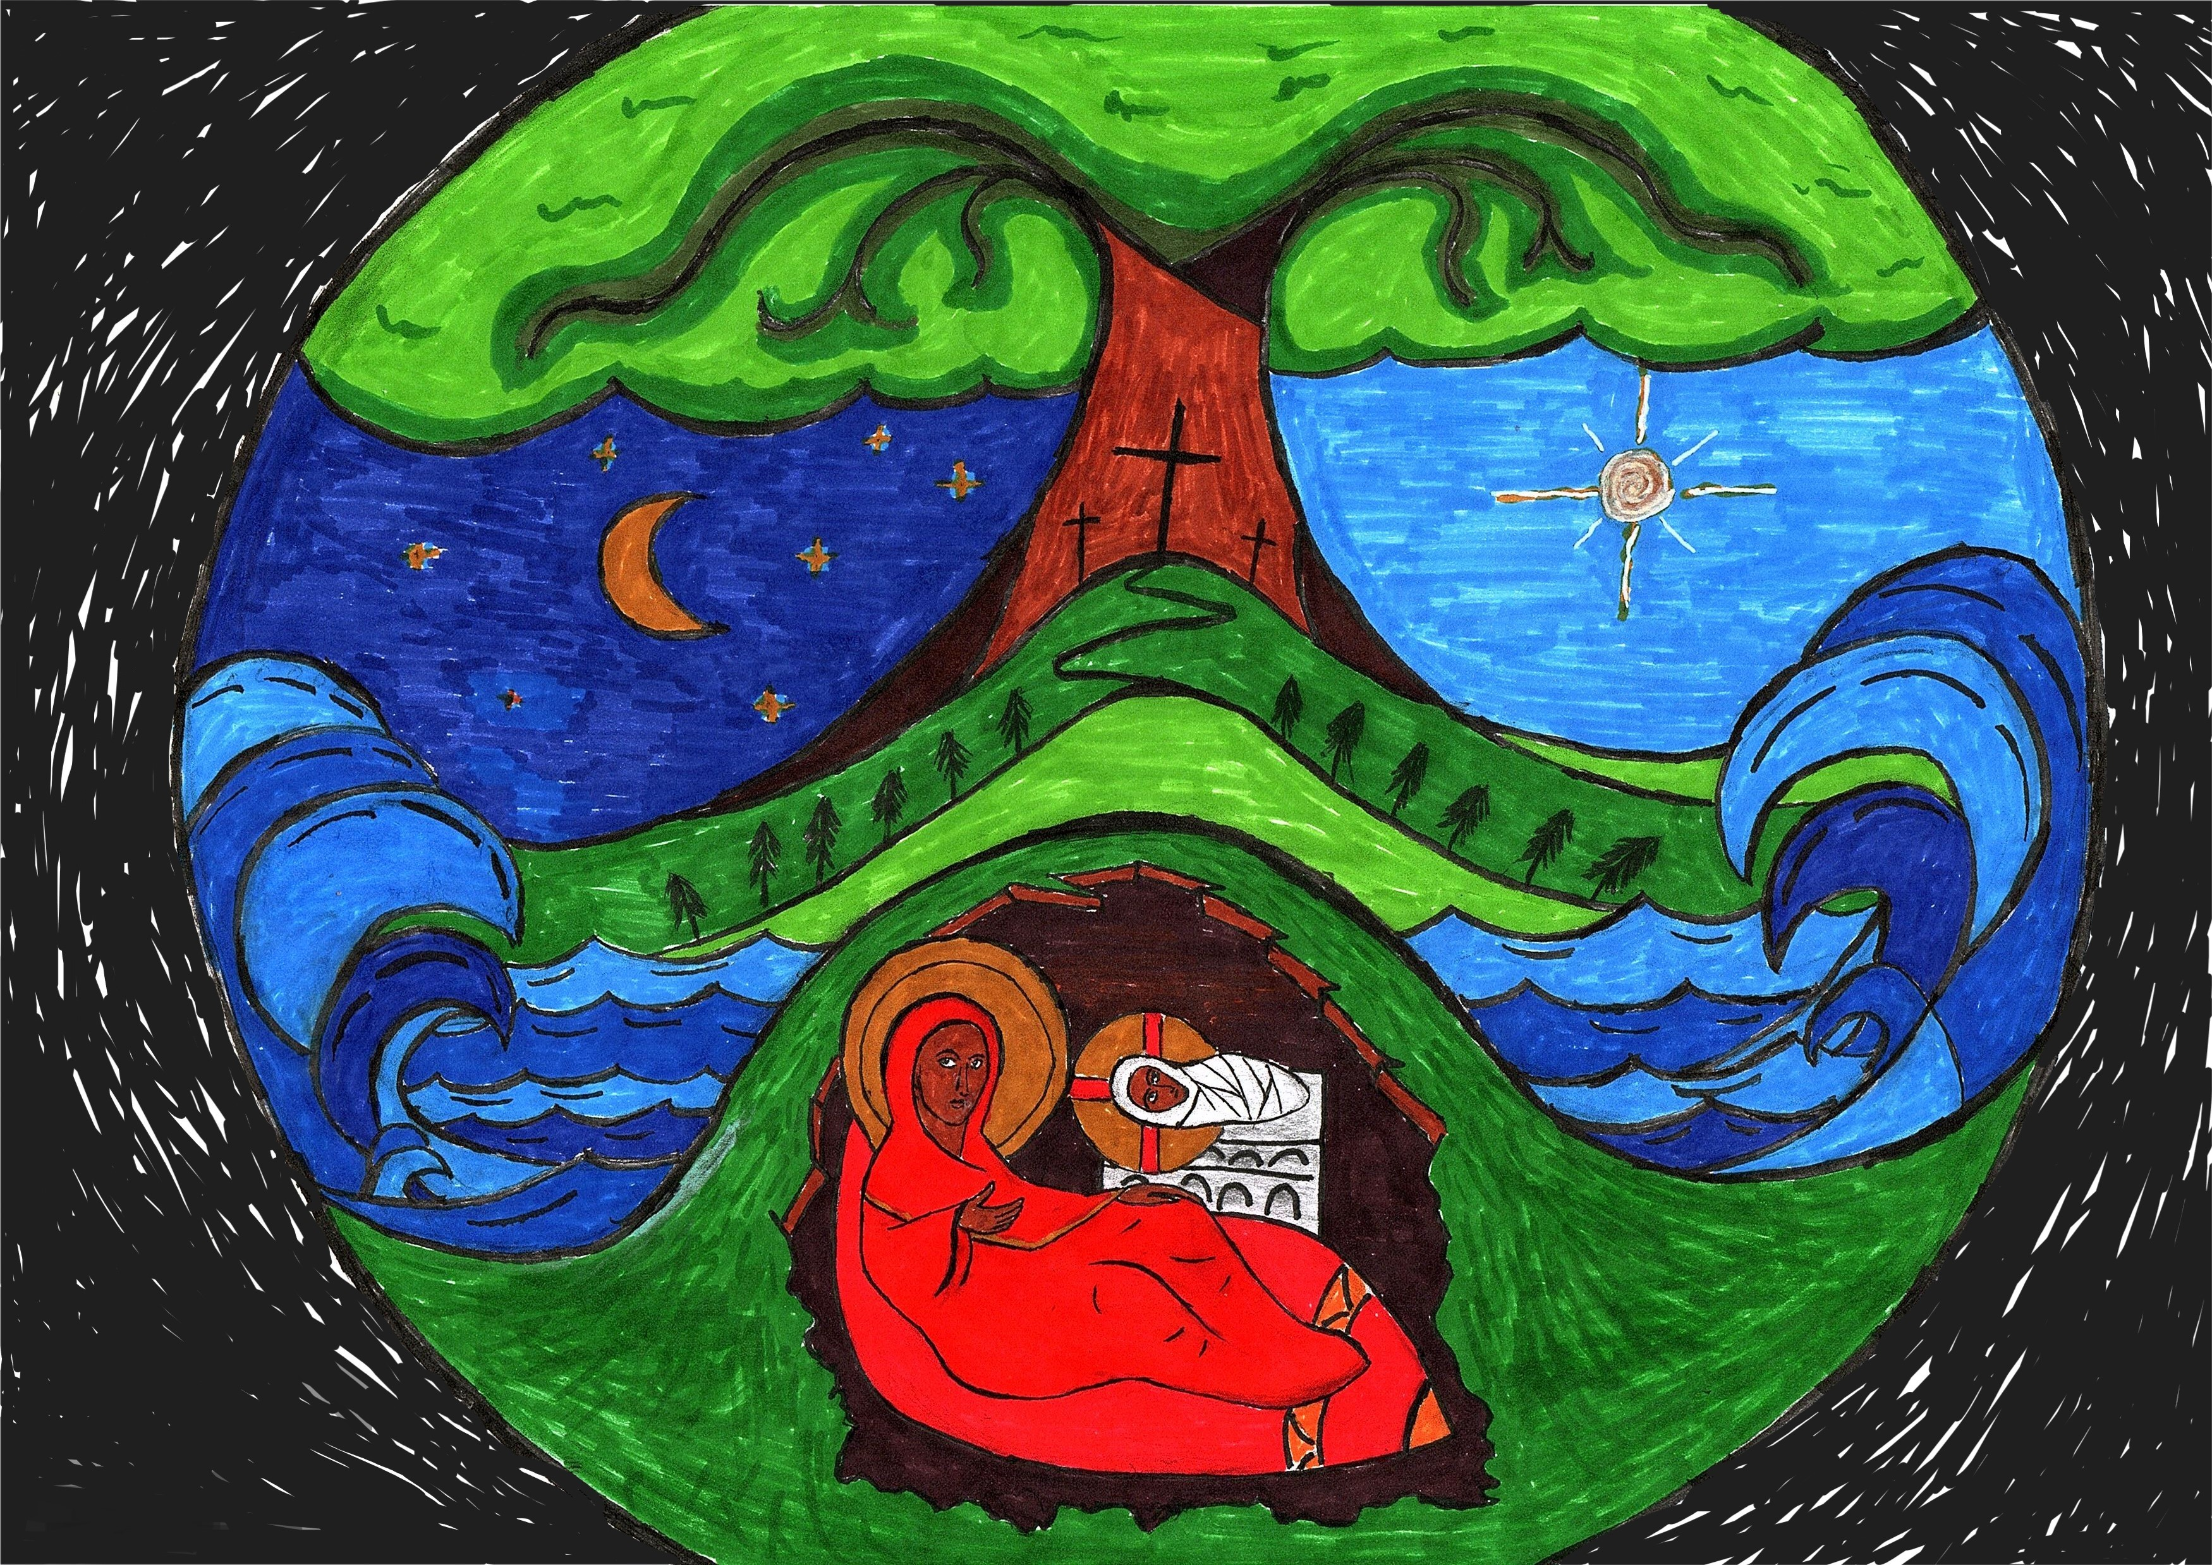

Callum’s Christmas card will be available for sale for £1. It is to be used on the Diocesan Facebook page. However, as is usual, we will not give each other within the congregation a Christmas card, but instead make a donation to Shelter Scotland. A basket for donations is at the back.

Thank you to everyone who attended the AGM last week. Easier than last year when we had to hold it twice! The accounts have now been sent to the Diocese and OSCR.

Bishop Bob Gillies has co-written a book entitled The Promised Dawn, price £10, which is suitable for private or Lenten study. See Kathy if you are interested.

DIOCESAN PRAYER DIARY
Please pray for:
College of Bishops , Bishop Ian
Diocese of Brechin – Bishop Andrew
Strathearn Group – St Columba, Crieff;
St Serf, Comrie; St Angus, Lochearnhead, St Fillan, Killin Gennie Evans

Next Sunday 17 December 2023
Carol Service
Organist: David
Readers: Frank, Janet, Russell, Betty, Michael, Ann, Charlotte, Kathy
Mulled wine and mince pies to follow

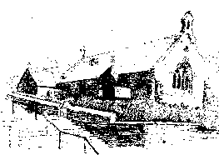
St MARY’s
Scottish Episcopal Church
Charity no SC003380
www.stmaryschurchnewportontay.org

The Revd Kathy Barrable, MEd, MTh
07552 503859
Grace and Peace be with you

10 December – Advent 2

Welcome
Introit Hymn On Jordan’s bank, the baptist’s cry 27
Collect for Purity
Confession
Absolution
Kyrie (on laminated sheet)
NO GLORIA
Collect of the Day
Readings Betty
Gradual Hymn The Lord will come and not be slow 29
Gospel
Sermon
Nicene Creed
Intercessions Ann
Peace
Offertory hymn Lord, Thy word abideth 166
Eucharistic Prayer 1
The Lord’s Prayer (sung)
Communion Song (on laminated sheet)
Communion is now received
Post Communion Prayer (back of leaflet)
Blessing
Recessional hymn Thy kingdom come! 178
Dismissal

WELCOME TO EACH VISITOR. We hope you enjoy God's message of faith, hope and love! We invite you to receive communion if you have been baptized.
Please be assured that the chalice is wiped with 99% food grade alcohol between each communicant. If you would rather receive the bread only, this is fine.

However, intinction (dipping the wafer into the wine) is NOT permitted.

