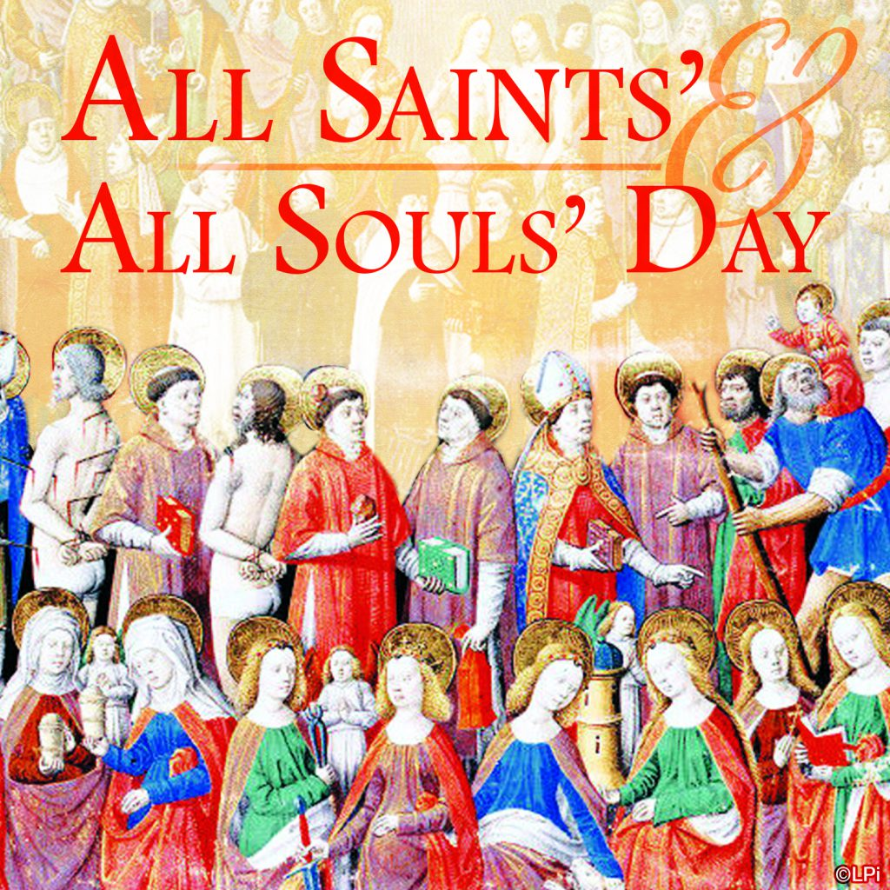

Next Sunday, Remembrance Sunday, there will be the usual short service at the war memorial at 12.05 prompt, after our service.
A reminder that the following week, Sunday 19th November is a joint service at Tayport to celebrate the feast of St Margaret, and there will be no service here.
FOOD IN FIFE study. This is an 8 week food waste survey that anyone is invited to join. Please see the poster at the back; applications are to be in as soon as possible.
The food basket will be taken to the foodbank at the end of November, in time for Christmas distributions.
DIOCESAN PRAYER DIARY
Please pray for:
College of Bishops , Bishop Ian
Diocese of Argyll and the Isles
All Saints, St Andrews
Alasdair Coles, Giles Dove, Anne Haselhurst,Ian Michael, Bob Harley

Next Sunday 12 November 2023
REMEMBRANCE SUNDAY
Revd Gareth Saunders presiding

Organist: David
Set up: Doreen
Reception David
Reader Michael
Intercessions Ann
Coffee: Betty



St MARY’s
Scottish Episcopal Church
Charity no SC003380
www.stmaryschurchnewportontay.org

The Revd Kathy Barrable, MEd, MTh
07552 503859
Grace and Peace be with you

5 November 2023 All Saints/All Souls

Welcome
Introit Hymn Lo, round the throne….. 303
Collect for Purity
Confession
Absolution
Kyrie (on laminated sheet)
Gloria (on laminated sheet)
Collect of the Day
Readings Betty
Gradual Hymn Glory to thee, O God 363
Gospel
Sermon
Nicene Creed
Intercessions Callum
Peace
Offertory hymn Ye holy angels bright 198
Eucharistic Prayer
The Lord’s Prayer (sung)
Communion Song (on laminated sheet)
Communion is now received
Post Communion Prayer (back of leaflet)
Blessing
Recessional hymn For all the saints 305
Dismissal

WELCOME TO EACH VISITOR. We hope you enjoy God's message of faith, hope and love! We invite you to receive communion if you have been baptized.

Please be assured that the chalice is wiped with 99% food grade alcohol between each communicant. If you would rather receive the bread only, this is fine.

However, intinction (dipping the wafer into the wine) is NOT permitted.

