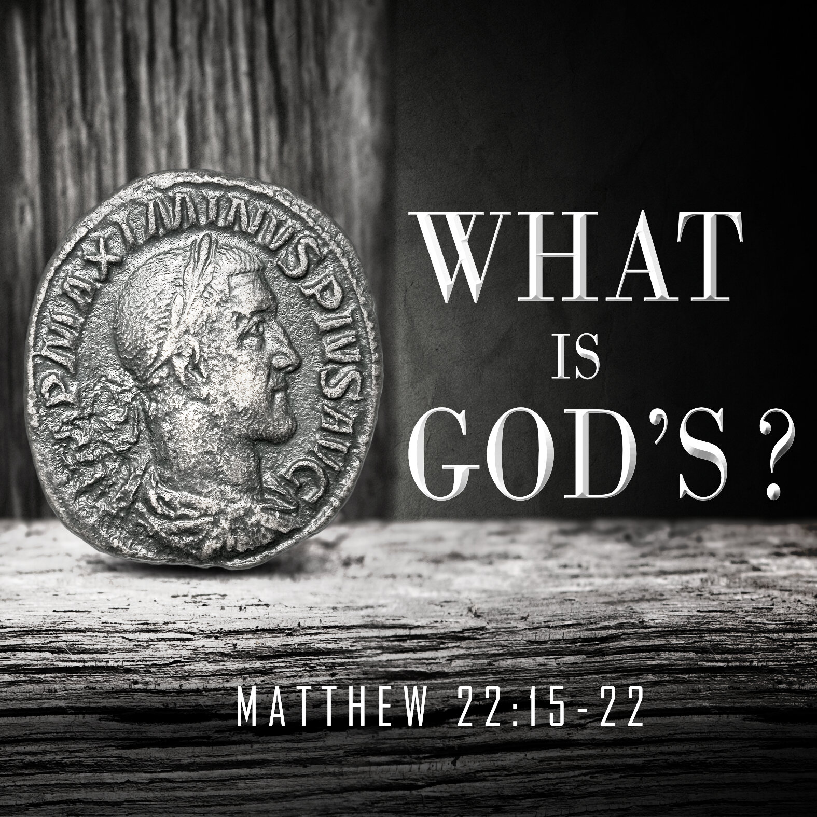

The Diocesan Environment Group (DEG) wish to invite you to attend their Event on Saturday 28th October between 10am and 4pm at St Luke’s Glenrothes
Guest speakers and discussion time..
This event is designed to support charges understand Net Zero and make plans for the future.
Please let Betty know if you wish to attend.

Saturday 4th November at 11.30am
SECMA Service of Thanksgiving in St Mary’s Cathedral, Edinburgh.
See poster at the back of the church.

DIOCESAN PRAYER DIARY
Please pray for:
College of Bishops , Bishop Ian
St Peter, Kirkcaldy with St Leonard and St Margaret, Kinghorn.
Christine Fraser Bob Barrett

Next Sunday 29 October 2023
Revd Gareth Saunders presiding
Organist ; Ron
Set up: David
Reception Betty
Reader Michael
Intercessions Frank
Coffee: Katherine

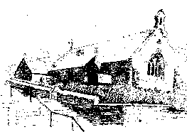

St MARY’s
Scottish Episcopal Church
Charity no SC003380
www.stmaryschurchnewportontay.org

The Revd Kathy Barrable, MEd, MTh
07552 503859
Grace and Peace be with you

22 October 2023 Pentecost 21

Welcome
Introit Hymn Glorious things of thee are spoken 172*
Collect for Purity
Confession
Absolution
Kyrie (on laminated sheet)
Gloria (on laminated sheet)
Collect of the Day (back of leaflet)
Readings Janet
Gradual Hymn Help us, O Lord, to learn 373
Gospel
Sermon
Nicene Creed
Intercessions Frank
Peace
Offertory hymn Happy are they, they that love God 176
Eucharistic Prayer
The Lord’s Prayer (sung)
Communion Song (on laminated sheet)
Communion is now received
Post Communion Prayer (back of leaflet)
Blessing
Recessional hymn To God be the glory 271#
Dismissal

*omit starred verse
# New Hymns and worship songs

WELCOME TO EACH VISITOR. We hope you enjoy God's message of faith, hope and love! We invite you to receive communion if you have been baptized.

Please be assured that the chalice is wiped with 99% food grade alcohol between each communicant. If you would rather receive the bread only, this is fine.

However, intinction (dipping the wafer into the wine) is NOT permitted.

