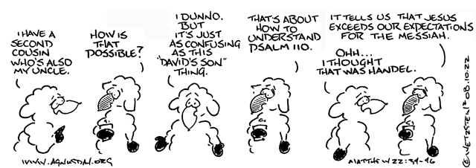

Apologies for the cartoon, I couldn’t resist it!

Please include Kathy in your prayers as she recuperates after her procedure in hospital on Thursday.

Saturday 4th November at 11.30am
SECMA Service of Thanksgiving in St Mary’s Cathedral, Edinburgh.
See poster at the back of the church.

DIOCESAN PRAYER DIARY
Please pray for:
College of Bishops , Bishop Ian
St John, Forfar with St Margaret, Lunanhead
Interim pastor Kim Lafferty
Chapel at Glamis Castle
Giles Dove

Next Sunday 5 November 2023
ALL SAINTS

Organist: David
Set up: David
Reception Doreen
Reader Betty
Intercessions Callum
Coffee: Betty

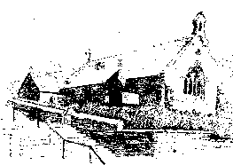

St MARY’s
Scottish Episcopal Church
Charity no SC003380
www.stmaryschurchnewportontay.org

The Revd Kathy Barrable, MEd, MTh
07552 503859
Grace and Peace be with you

29 October 2023 Pentecost 22

We welcome Revd Gareth Saunders today

Welcome
Introit Hymn Love divine, all loves excelling 131
Collect for Purity
Confession
Absolution
Kyrie (on laminated sheet)
Gloria (on laminated sheet)
Collect of the Day (back of leaflet)
Readings Betty
Gradual Hymn Lord, thy word abideth 166
Gospel
Sermon
Nicene Creed
Intercessions Frank
Peace
Offertory hymn Happy are they, they that love God 176
Eucharistic Prayer
The Lord’s Prayer (sung)
Communion Song (on laminated sheet)
Communion is now received
Post Communion Prayer (back of leaflet)
Blessing
Recessional hymn God is Love, let heav’n adore Him 365
Dismissal

WELCOME TO EACH VISITOR. We hope you enjoy God's message of faith, hope and love! We invite you to receive communion if you have been baptized.

Please be assured that the chalice is wiped with 99% food grade alcohol between each communicant. If you would rather receive the bread only, this is fine.

However, intinction (dipping the wafer into the wine) is NOT permitted.

