CHRISTIAN AID WEEK: Extraordinary Love

Order of Service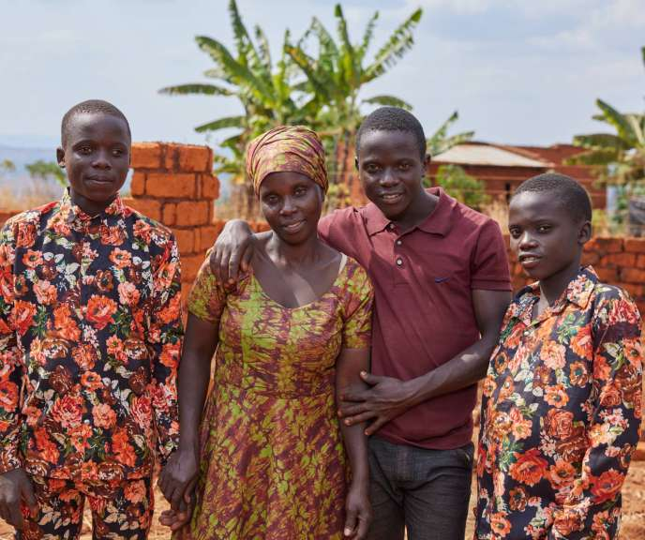
Welcome
Our service today is about extraordinary love.
God’s love for each of us exceeds what we can imagine.
We are called to live out that love in service to one another.
Our guide leading us through our worship today is Aline Nibogora from Makamba Province in Burundi. Married when she was still a child, Aline experienced domestic violence, homelessness, and extreme poverty. She was brought to a point where she says that ‘people forgot I was human’. But Aline’s love for her children, and her experience of God’s love, filled her with exceptional courage. She was determined to give her children a better life and to help her neighbours.
Hymn
Call to worship (based on 1 John 3.1)
We gather as children of God, bound to one another by love. See what love the Father has given us. We gather to live out our calling to love our neighbours and our enemies. See what love the Father has given us. We gather to experience in word and song, in prayer and worship, the overflowing compassion and tenderness of our God. See what love the Father has given us.
Aline’s Story – Part One Burundi is one of the poorest countries in the world financially. More than 70% of the population live in poverty. Most people get their living through farming. Farmers have been significantly affected by the climate crisis, facing droughts, floods and landslides. Many families eat just one meal a day. Philip Galgallo, Country Director of Christian Aid Burundi tells us: ‘I think the biggest worry for most Burundian mothers is how they’ll feed their children.’ On top of all this Aline Nibogora faced extra challenges. She was abused by her husband and forced out of her home, becoming separated from her children. With nowhere to live and worrying daily about her children’s safety, Aline was pushed into the most extreme poverty.

Opening Prayer Aline told Christian Aid: “God comforts you through troubled times and gives you hope for a better future.” So, we begin our worship by praying together with Aline and with Christians around the world. God our comforter, Source of our hope, Be present to us today. Unite us as we worship. Give us ears to hear the Good News of your abundant, transformative love. Stir up in us a prophetic voice, that we may proclaim the coming of your kingdom. Inspire in us the courage to serve you in word and deed, as together we build a world free from poverty.
Amen.
Prayer of confession
Creator God, you made us and cherish us as your beloved creation.
We confess that we have failed to care for the world you brought into being.
We have polluted the earth; we have consumed without thought for the future. We have hardened our hearts and turned away from
communities devastated by the climate crisis.
Out of the greatness of your love.
Lord, forgive us.
Jesus, you call us to love our neighbour, to go the extra mile.
We confess that we have failed to love others as you love us.
Too often we have ignored cries for justice.
We have given our energies to protecting what is ours
And have failed to consider the needs of others.
Out of the greatness of your love.
Lord, forgive us.
Spirit of truth, you breathe wisdom upon us and guide our ways.
We confess those times we have relied on ourselves alone, as though we had no need of you;
Those times we have rejected the help our neighbours offer because it would cost us our pride.
We have declared ourselves dry ground, unable to grow the fruits of love, peace, joy and gentleness.
Yet through all our failings and faults you never leave us.
Out of the greatness of your love.
Lord, forgive us.
Aline’s Story – Part Two
Aline told Christian Aid about life when she was homeless: “I wandered the streets, asking anyone for a place to sleep. Those who showed me kindness would let me stay for two or three days, but it was difficult. People would insult me and treat me with contempt. They forgot I was a human being. It filled me with sorrow.” Aline never gave up. Pushed to the brink of survival, she pushed back.
Aline joined a community workshop led by Christian Aid-funded trainers. She learnt about Village Savings and Loans Associations and was determined to form her own to help herself and others around her. Village Savings and Loans Associations offer a way for community groups to manage, save and lend money. Aline was able to get a start-up loan and began trading avocados and peanuts. She was also able to buy a bicycle so that she could transport her goods.
Christian Aid Collect Loving God, Help us to hear the voices of those enduring extreme poverty. It is hard to listen to stories of pain. Show us how compassion for others can bring healing and fullness of life for all. Help us to understand that we are one through your love, for every human being is loved by you, beyond measure. Loving God, you call on us to build your kingdom of justice, mercy, and truth. It isn’t a task for the faint-hearted. When we lose our sense of purpose, fill us with faith. When we doubt or throw up our hands in despair, fill us with hope. When we pass by our neighbour as though we did not know them, Fill us with the love that turns us back and takes us to their aid. In Jesus’ name, Amen
First reading – 1 Corinthians 13.1-13
Hymn
Aline’s Story – Part Three
Aline’s business was successful and she was able to rent a house. At last she was reunited with her three eldest sons who came to live with her. She is hopeful that one day she will be together with all of her children. Aline can now afford food for herself and her family. She has bought solar panels so that her children can have light to help them study.#Now Aline is baking her own bricks and building a stronger home for her family, in every sense. Aline told Christian Aid: ‘We pray together as we are still alive thanks to God’s grace.
Second reading – Mark 12.28-31
Prayers of Intercession
Let us pray together.
Give thanks to the Lord, for he is good. His love endures forever.
Aline praying in her home with her family. God we are thankful for your love: love that changes us, turns our priorities upside down, and yet somehow makes us more fully ourselves. We offer our gratitude for those who have shown us tenderness, care and compassion; Those who have seen us through troubled times and brought us hope. We pray for those we love and for those we have failed to love.
Remembering Aline’s experience, we hold in mind people around the world who know what it is to be treated as less than human.
May we work together to uphold the dignity of every human being, so that no one feels forgotten. God whose love endures forever, Hear our prayer.
God we are thankful for those who inspire us with their strength, courage and perseverance.We pray for people around the world brought to the brink by extreme poverty, struggling to survive. We pray especially for families in Burundi who do not have sufficient food, clean water, or access to healthcare. Fuel us with the fire of your spirit. Fill us with a fierce determination to end the outrage of poverty. May we hear the cries of those who are excluded from power. May we speak up withthem for a more equal and just world. God whose love endures forever, Hear our prayer.
God we are thankful for peacemakers and healers. We pray for all those who are reaching across divisions and acting to end violent conflict. May political leaders use their power wisely to further the cause of peace.We pray especially for …
[Pray here for places and people affected by war and violence. You may wish to include prayers for:
Peace in the Middle East An end to the war in Ukraine
Those affected by conflict in Sudan
Ongoing peace-making work in Burundi]
We remember with sorrow the lives lost in conflict.
God whose love endures forever,
Hear our prayer.
God we are thankful for love in action. We give thanks for the cake-bakers, the runners, the envelope-collectors. We are grateful for those who give their time, energy and resources to sponsored walks, craft sales, sing-a-thons, cycles, swims, and to all kinds of fundraising challenges. We pray that each of us may recognise the gifts we have to share, and that we may see too the richness of our neighbour’s gifts and talents. Help us to remember that ending poverty is not just about the things money can buy: It’s also about the joyful living that you desire for each of us. May we all be free to live life joyfully, in all its fullness. God whose love endures forever, Hear our prayer. God, we are thankful that you offer comfort to us in our sorrows. We give thanks that when everything else around us seems to crumble, you promise us that your love will remain solid and steadfast. Thinking of all that Aline has been through, we pray for her, her children and her community. We pray for others known to us who are suffering. [Remembering particularly …] We pray for those who have lost someone they love. [Remembering particularly… ] May those who grieve know your peace. We offer these prayers in Jesus’ name. Give thanks to the Lord, for he is good. His love endures forever. Amen.
The service continues with the PEACE,
Steadfast love and faithfulness will meet;
righteousness and peace will kiss each other. (Psalm 85.10)
OFFERTORY HYMN
EUCHARIST

POST COMMUNION PRAYER
God, Father, Son and Holy Spirit, you have abundantly blessed us,
your mercy knows no bounds.
We offer these gifts and commit ourselves to action,
following your command to love one another. We give thanks for the vital work of Christian Aid and for all who support this work. May these offerings transform the prospects of those living in extreme poverty. God of justice, mercy, and peace, send us out to serve you.
May your extraordinary love radiate through our words and actions, every day of our lives. Amen.
BLESSING
May we persevere in faith,
May we go out in hope,
May we act and speak with love,
By the grace of God, our creator, redeemer, and comforter,
Amen.

FINAL HYMN

